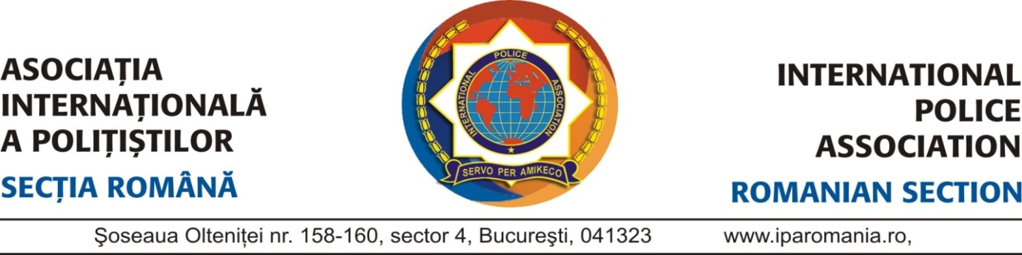

Dear National IPA Presidents,
Dear IPA Friends,

The Romanian Section of the International Police Association has the great honor to invite you to attend the event of the

1st INTERNATIONAL POLICE WOMEN’S MEETING
„DANUBE DELTA 2017” – ROMANIA
JUNE 21 - 26, 2017

Event organized by IPA Romania, between June 21 - 26, 2017

- The social program includes visiting a unique place in Europe and in the world, the Danube Delta, including a cruise trip on the Danube, and other touristic attractions.
- English language will be the main language used in communication and English translation will be provided during the meeting sessions.
- Further, you will find a brief description of the beautiful places we will be visiting during the Meeting period of 21 to 26of June, 2017.
For a short preview of the main touristic objectives, please visit the links below:
https://www.youtube.com/watch?v=wo6hEEIgChY
https://www.youtube.com/watch?v=_q34jFyXaYE
https://www.youtube.com/watch?v=hNrAWooy1e0
https://www.youtube.com/watch?v=DTVhVpJInfg
1st INTERNATIONAL POLICE WOMEN’S MEETING
„DANUBE DELTA 2017” – ROMANIA
JUNE 21 - 26, 2017

APPLICATION FORM

- The arrivals and the departures for the event will be made on Otopeni Airport-Bucharest

Name: _____________________________Surname:______________________________________
Delegate□ Other□
Tel:__________________________________ E-mail______________________________________
IPA Section ____________________________Country:____________________________________
ARRIVAL: (X) Car____Flight_____Train_______Bus______Other_____
Date:_________________________________ Time:____ :______
Flight:________________________________ Airline:___________________________________
Accomodation: Single (__)
Double (__) twin / double (__)
Sharing with:______________________________________________________________________
DEPARTURE:
Date:_________________________________ Time:____ :______
Flight:________________________________ Airline:___________________________________
Shirt size: S□ M□ L □ XL□ XXL□
Date: ___________________ Signature:__________________________________
The application forms, together with the confirmation of payment are to be submitted by electronic mail to: c.marin@iparomania.ro by May 1, 2017 at the latest.
PAYMENT DETAILS

June 21 - 26, 2017
Prices:
Doube room 295,00 € per person
Single room 335,00 € per person
Fares include: - Transfer from Otopeni Airport to the HELLO Hotel
- Accomodation at HELLO Hotel, Bucharest and NEW HOTEL EGRETA, Tulcea.
- Meals
- Conference program
- Entry tickets to MACIN VINERY, PARLIAMENT HOUSE, cruise to the DANUBE DELTA
- Transportation by bus to Tulcea and back
- Sightseeing passes to main touristic attractions in Bucharest and Tulcea.
Method of payment: Bank transfer
BANK ACCOUNT DETAILS
Account Name: ASOCIAŢIA INTERNAŢIONALA A POLIŢIŞTILOR SECTIA ROMANA IBAN: RO15BPOS85002717812EUR01
Bank Swift Code: BPOS ROBU
Bank name: : BANCPOST S.A. SUCURSALA LIBERTATII
Address: Bld. Libertatii, nr.20, Bl.103, Sc.A, Sector 5, Bucureşti, 050707
The application forms, together with the confirmation of payment are to be submitted by electronic mail to: c.marin@iparomania.ro by May 1, 2017 at the latest.
Refunds will not be possible for cancellation requests submitted after this date.
The Romanian Section is bound to acknowledge receipt of the application form and the participation payment.
For additional information, please email c.marin@iparomania.ro

<< We will experience an unforgettable tour of the unique Danube Delta >>

1st INTERNATIONAL POLICE WOMEN’S MEETING
„DANUBE DELTA 2017” – ROMANIA
JUNE 21 - 26, 2017

PROGRAMME

Wednesday Arrival of delegates & guests and transfer to the HELLO Hotel
21.06.2017
19.00-20.00 Bucharest City Tour
20.00 Dinner at the Brewery H Pub

Thursday
22.06.2017
07.00-09.00 Breakfast (check-out)
09.00-10.00 Transportation by bus to Parliament House
10.00-12.00 Sightseeing tour of Parliament House
12.00-15.00 Transportation by bus to MacinVinary
15.00-17.00 Wine tasting and lunch
17.00-19.00 Transportation by bus to the Danube Delta
20.00-22.00 Dinner at New Hotel Egreta

Friday
23.06.2017
08.00-10.00 Breakfast
10.00-11.30 Meeting session (official presentation of the Danube Delta made
by the Deputy Governor of the Danube Delta)
11.30-11.45 Coffee break
11.45-12.45 Meeting session
12.45-13.00 Official photograph
13.00-14.30 Lunch
14.30-20.00 Free program
20.00 Dinner at New Hotel Egreta
Artistic show performed by ,,Baladele Deltei” Artistic Assembly
Saturday
24.06.2017
08.00-10.00 Breakfast
10.00-13.00 Cruise to the Danube Delta
13.00-14.30 Lunch
14.30-20.00 Free program (swimming, bowling, etc)
20.00 Official dinner party

Sunday
25.06.2017
08.00-10.00 Breakfast
10.00-13.00 Free program
13.00-13.30 Check-out
13.00 Transportation by bus to HELLO Hotel – Bucharest
19.00-21.00 Dinner at EXCELSIOR RESTAURANT

Monday
26.06.2017
08.00-10.00 Breakfast
- Check-out and departures

<< Family members and friends of the delegates are welcome
to attend the meeting! >>

