POLICING IN THE TIME OF PANDEMIC
A Workshop Series
‘Police Operations and Crises’ – Roger GOMM QPM
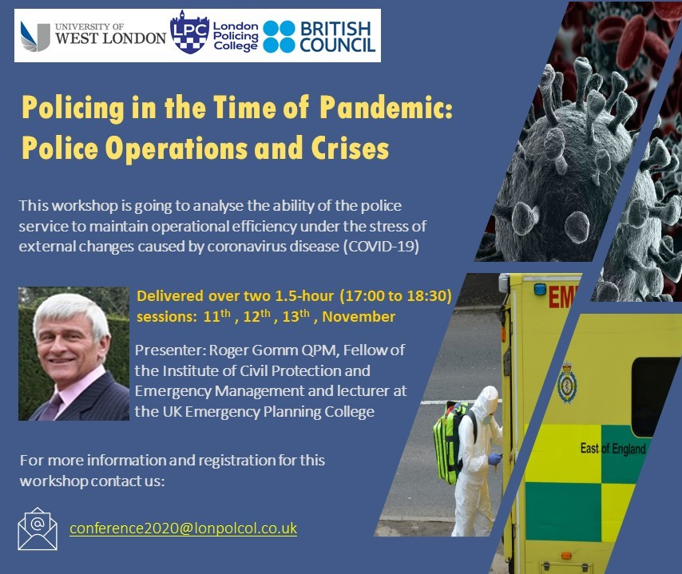

Workshop 1-Crisis Management
‘The ability to maintain operational efficiency under the stress of external changes-
Police Service Crisis Management’

Date: Wednesday 11th November, Thursday 12th October and Friday 13th October 2020
Abstract:
Day 1 – Wednesday 11th November
Session 1: As an introduction to crisis management we will compare different types of incidents and the; operational and academic terms (wicked problems) used. Always remembering that ‘there is no such things as a ‘Random Event’.
Session 2: A review the basic incident management process: Risk Assessment (What are the problems?) – Risk Controls (What should we do about it?) – Contingency Planning (What do we do if it goes wrong?). Discussion: Incident Management; Are you and your organisation ‘Prepared’?
Day 2 – Thursday 12th November
Session 3: Preparing to respond: Overview of UK incident command structures; Gold/Strategic, Silver/Tactical, Bronze/Operational, with an insight into their roles and responsibilities. Where does UK COBR fit in?
Session 4: Preparing people to work at the Strategic level. The first three core functions: situation; direction; action. Consider what is situational awareness and a useful tool to help you think it through; SDI – Scale, Duration and Impact which is where the creation of shared situational awareness begins, with the 3 most basic things you need an answer to.
Delegates: As preparation for the final day the delegates to complete ‘local’ assessment of the situation; identify the wider impacts and consequences of coronavirus disease (COVID-19). A template will be provided to guide thinking.
Day 3 – Friday 13th November
Session 5: Situation: the current coronavirus disease (COVID-19). An interactive process assessing the wider impacts and consequences of coronavirus disease (COVID-19), primarily from a from a policing (safety and security) perspective. The workshop will use the assessment tool: Scale, Duration and Impacts to demonstrate the process.
Session 6: Discussion and comments on the assessment
Paper Topics
- Analysis the ability of the police service to manage the wider impacts and consequences of coronavirus disease (COVID-19)

- Analysis the ability of the police service to maintain operational efficiency under the stress of external changes caused by coronavirus disease (COVID-19)

Presenter: Roger GOMM QPM
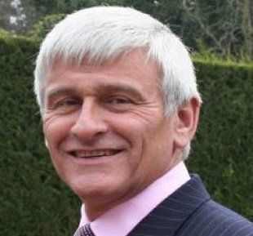
Roger retired from the Metropolitan Police Service having successfully completed a thirty-four-year career in 2012. He has a unique background in operational command having been pivotal in all major events in London for over 14 years. Accustomed to working at executive and tactical levels, he is well practiced in strategic risk management, managing complex threats to people, property, places and reputation, achieving business continuity and managing specialist teams with national and international responsibilities. He developed command centre processes and training programmes to prepare individuals and teams to command major events, including the 2012 London Olympics. He designed and successfully delivered leadership, incident management training and exercises to a variety of audiences in the UK and abroad. His professional and personal commitment was recognised by Her Majesty in 2007 when he was awarded the Queens Police Medal for distinguished Service. Roger is now working as an Advisor, Trainer or Consultant and his portfolio includes; Associate Lecturer, Cabinet Office Emergency Planning College; Associate Tutor, College of Policing; Visiting Lecturer at several Universities; Editorial Panel Member for Crisis Response Journal; and a number of risk, crisis management and security projects with organisations. He also worked as an Advisor as part of security planning for 2022 FIFA World Cup for 18 months. Roger is a Fellow of the Institute of Civil Protection & Emergency Management (FICPEM), Fellow of the Security Institute (FSyI), Fellow of the Chartered Management Institute (FCMI) and Fellow of the Institute of Leadership and Management (FInstLM). He has a Diploma in Teaching in the Lifelong Learning Sector (DTLLS), Qualified Teacher Learning and Skills status (QTLS) and a Member of the Society for Education and Training (MSET)
LINKS TO LOG IN

Please find below a login link for each session on GoToTraining. The platform works best from a laptop in desktop version.

Wednesday 11th November 2020
1700-1830
Invite Your Attendees
Registration URL: https://attendee.gototraining.com/r/3699907615418431746
Training ID: 204-140-012

Thursday 12th November 2020
1700-1830
Invite Your Attendees
Registration URL: https://attendee.gototraining.com/r/4512347752298429698
Training ID: 231-237-276

Friday 13th November 2020
1700-1830
Invite Your Attendees
Registration URL: https://attendee.gototraining.com/r/7695990267593633282
Training ID: 244-865-788

